BLOG 1
Give Your Kids the
Gift of Travel
http://bit.ly/34SVERL

BLOG 3
Mexico with
the Kids
http://bit.ly/2DAJa58

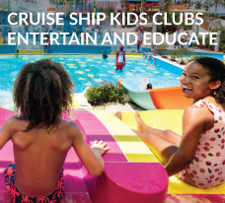

BLOG 2
Cruise Ship Kids Clubs
Entertain and Educate

http://bit.ly/2DQm1ff

BLOG 4
A Timeless
Bahamian Getaway
http://bit.ly/2sF5M27

