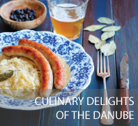

BLOG 1
Culinary Delights of the Danube
http://bit.ly/2JsDuh2

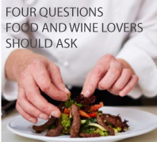

BLOG 3
Four Questions Food and Wine
Lovers Should Ask
http://bit.ly/2LguCxp

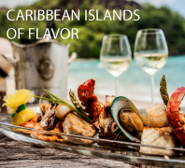

BLOG 2
Caribbean Islands of Flavor
http://bit.ly/2xIuaiw

BLOG 4
On Cloud Wine
http://bit.ly/2LN3PrQ

