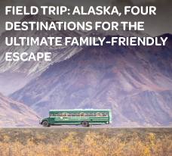

BLOG 1
Field Trip: Alaska, The Ultimate Family - Friendly Escape
https://bit.ly/alaska-dec-escape

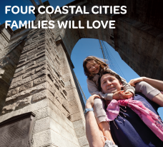

BLOG 3
Four Coastal Cities
Families will Love
https://bit.ly/4coastalcities-dec-escape

BLOG 2
Keep Your Family
Moving in Jamaica
https://bit.ly/jamaica-dec-escape

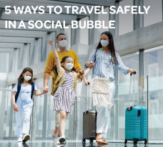

BLOG 4
5 Ways to Travel Safely
in a Social Bubble
https://bit.ly/bubble-dec-escape

