How to Update your Facebook Profile Picture with a Frame

- Go to your profile and hover over your profile pic and click “update”
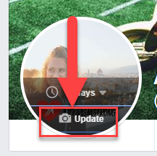
- Click “add frame”
- Search “travel leaders” and select the frame you want (we have two options available)
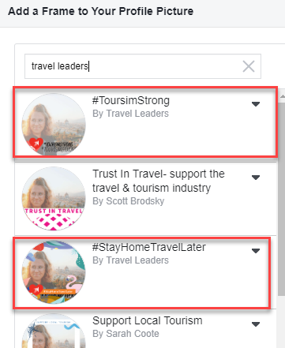

- Hit “use as Profile Picture”

