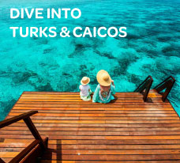

**BLOG 1  
DIVE INTO**

**TURKS & CAICOS**

**https://bit.ly/_turkscaicos**

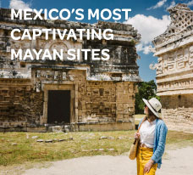

**BLOG 3**

**MEXICO’S MOST CAPTIVATING**

**MAYAN SITES**

**https://bit.ly/_mayansites**

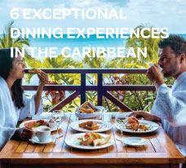

**BLOG 2  
6 EXCEPTIONAL DINING EXPERIENCES IN THE CARIBBEAN**

**https://bit.ly/_diningexperiences**

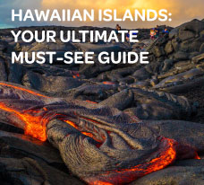

**BLOG 4**

**HAWAIIAN ISLANDS: YOUR**

**ULTIMATE MUST-SEE GUIDE**

**https://bit.ly/_hawaiianislands**