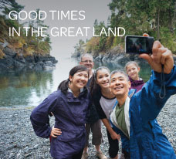

BLOG 1
GOOD TIMES
IN THE GREAT LAND
https://bit.ly/good-times-in-great-land

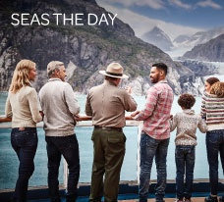

BLOG 3
SEAS THE DAY
https://bit.ly/seas-the-day-

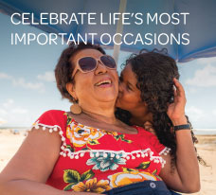

BLOG 2
CELEBRATE LIFE’S
MOST IMPORTANT OCCASIONS

https://bit.ly/celebrate-life-occasions

