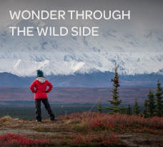

BLOG 1
WONDER THROUGH THE
WILD SIDE
https://bit.ly/wonder-through-the-wild-side

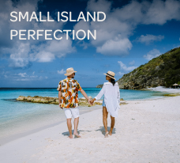

BLOG 3
SMALL ISLAND PERFECTION
https://bit.ly/small-island-perfection

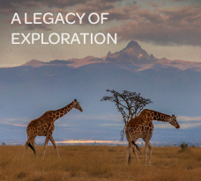

BLOG 2
A LEGACY OF EXPLORATION

https://bit.ly/a-legacy-of-exploration

