BLOG 1
THE VALUE OF
TRAVEL ADVISORS
https://bit.ly/the-value-of-travel-advisors

BLOG 3
RIO DE JANEIRO
AFTER DARK
https://bit.ly/Rio-de-Janeiro-After-Dark

BLOG 2
EXPERT’S VIEW
A LEGACY OF LUXURY

https://bit.ly/legacy-of-luxury

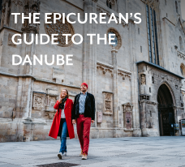

BLOG 4
THE EPICUREAN’S
GUIDE TO THE DANUBE
https://bit.ly/epicureans-guide-to-the-danube

