

**BLOG 1  
COME ALONG WITH**

**CELEBRITY CRUISES**

[**https://bit.ly/QA_Celebrity**](https://bit.ly/the-value-of-travel-advisors)

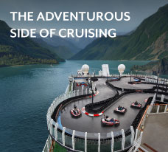

**BLOG 3**

**THE ADVENTUROUS**

**SIDE OF CRUISING**

[**https://bit.ly/adventurous_side_of_cruising**](https://bit.ly/adventurous_side_of_cruising)



**BLOG 2  
HIDDEN WONDERS**

**OF THE CARIBBEAN**

[**https://bit.ly/hidden_wonders**](https://bit.ly/hidden_wonders//bit.ly/legacy-of-luxury)



**BLOG 4**

**TRAVEL HACKS**

**FROM THE PROS**

[**https://bit.ly/travel_hacks_from_the_pros**](https://bit.ly/travel_hacks_from_the_pros)