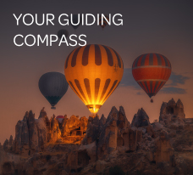

**BLOG 1  
YOUR GUIDING**

**COMPASS**

[**https://bit.ly/your-guiding-compass**](https://bit.ly/your-guiding-compass)

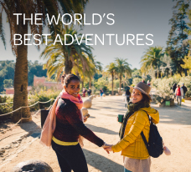

**BLOG 3**

**THE WORLD’S**

**BEST ADVENTURES**

[**https://bit.ly/best-adventures**](https://bit.ly/best-adventures)

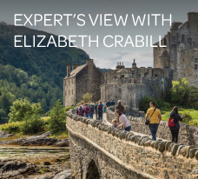

**BLOG 2  
EXPERT’S VIEW**

**WITH ELIZABETH CRABILL**

[**https://bit.ly/experts-view-elizabeth-crabill**](https://bit.ly/experts-view-elizabeth-crabill)

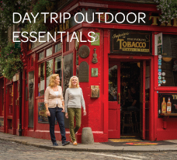

**BLOG 4**

**DAY TRIP**

**OUTDOOR ESSENTIALS**

[**https://bit.ly/trip-outdoor-essentials**](https://bit.ly/trip-outdoor-essentials)