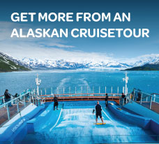

**BLOG 1  
GET MORE FROM AN**

**ALASKAN CRUISETOUR**

<https://bit.ly/experts-view>

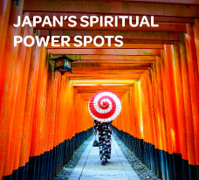

**BLOG 3**

**JAPAN’S SPIRITUAL**

**POWER SPOTS**

<https://bit.ly/japan-power-spots>

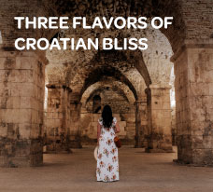

**BLOG 2  
THREE FLAVORS OF**

**CROATIAN BLISS**

<https://bit.ly/croatian-bliss>