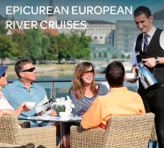

**BLOG 1  
EPICUREAN EUROPEAN**

**RIVER CRUISES**

[**https://bit.ly/epicurean-river-cruises**](https://bit.ly/epicurean-river-cruises)

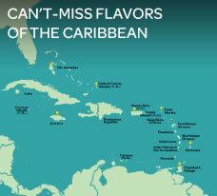

**BLOG 3**

**CAN’T-MISS FLAVORS**

**OF THE CARIBBEAN**

[**https://bit.ly/flavors-of-the-caribbean**](https://bit.ly/flavors-of-the-caribbean)

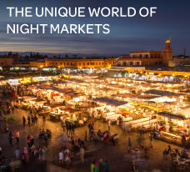

**BLOG 2  
THE UNIQUE WORLD OF**

**NIGHT MARKETS**

[**https://bit.ly/unique-world**](https://bit.ly/unique-world)