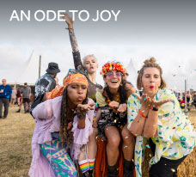

**BLOG 1  
AN ODE TO JOY**

[**https://bit.ly/an-ode-to-joy**](https://bit.ly/an-ode-to-joy)

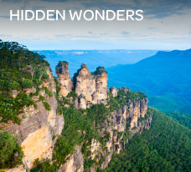

**BLOG 3**

**HIDDEN WONDERS**

[**https://bit.ly/australia-landmarks**](https://bit.ly/australia-landmarks)



**BLOG 2  
FRINGE FRONTIERS**

[**https://bit.ly/fringe-frontiers**](https://bit.ly/fringe-frontiers)

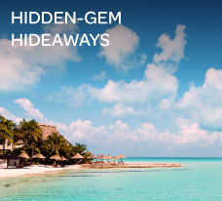

**BLOG 4**

**HIDDEN-GEM HIDEAWAYS**

[**https://bit.ly/hidden-gem-hideaways**](https://bit.ly/hidden-gem-hideaways)