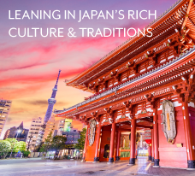

**BLOG 1  
Leaning into Japan’s Rich Culture**

**& Traditions**

[**https://bit.ly/japans-rich-culture**](https://bit.ly/japans-rich-culture)

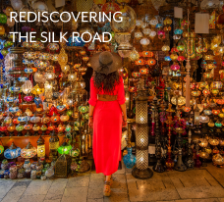

**BLOG 3**

**Rediscovering**

**the Silk Road**

[**https://bit.ly/rediscovering-the-silk-road**](https://bit.ly/rediscovering-the-silk-road)

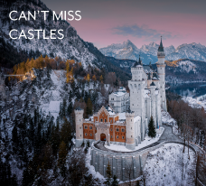

**BLOG 2  
Can't Miss**

**Castles**

[**https://bit.ly/cant-miss-castles**](https://bit.ly/cant-miss-castles)