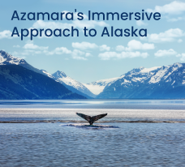

BLOG 1
Azamara’s Immersive
Approach to Alaska
https://bit.ly/azamaras-immersive-approach-to-alaska


BLOG 3
The Joy of Walking
https://bit.ly/the-joy-of-walking
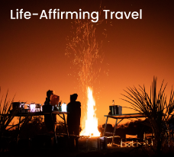

BLOG 2
Life-Affirming
Travel
https://bit.ly/life-affirming-travel

