

**BLOG 1  
Unveiling the Magic**

[**https://bit.ly/Unveiling-the-Magic**](https://bit.ly/Unveiling-the-Magic)



**BLOG 3**

**Delightfully Unexpected Water Sports**[**https://bit.ly/unexpected-water-sports**](https://bit.ly/unexpected-water-sports)

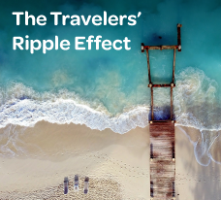

**BLOG 2  
The Travelers’ Ripple Effect**

[**https://bit.ly/the-travelers-ripple-effect**](https://bit.ly/the-travelers-ripple-effect)