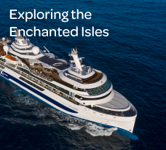

**BLOG 1  
Exploring the Enchanted Isles**

[**https://bit.ly/enchanted-isles**](https://bit.ly/enchanted-isles)

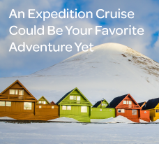

**BLOG 3**

**An Expedition Cruise Could Be Your Favorite Adventure Yet**[**https://bit.ly/expedition-cruise**](https://bit.ly/expedition-cruise)

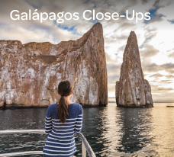

**BLOG 2  
Galápagos Close-Ups**

[**https://bit.ly/galapagos-close-ups**](https://bit.ly/galapagos-close-ups)