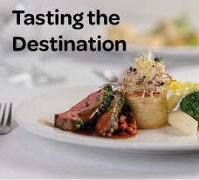

BLOG 1
Tasting the
Destination
https://bit.ly/tasting-the-destination
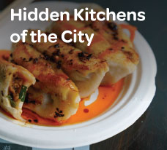

BLOG 3
Hidden Kitchens
of the City
https://bit.ly/hidden-kitchens-of-the-city
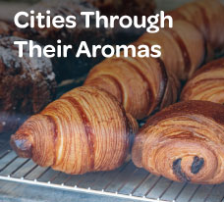

BLOG 2
Cities Through
Their Aromas
https://bit.ly/cities-through-their-aromas

