

BLOG 1
Elevating the Island
https://bit.ly/elevating-the-island
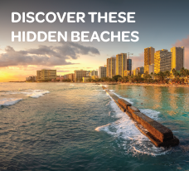

BLOG 3
Discover These Hidden Beaches
https://bit.ly/discover-these-hidden-beaches


BLOG 2
The World’s Best Sunsets
Worth Traveling For
https://bit.ly/the-worlds-best-sunsets

